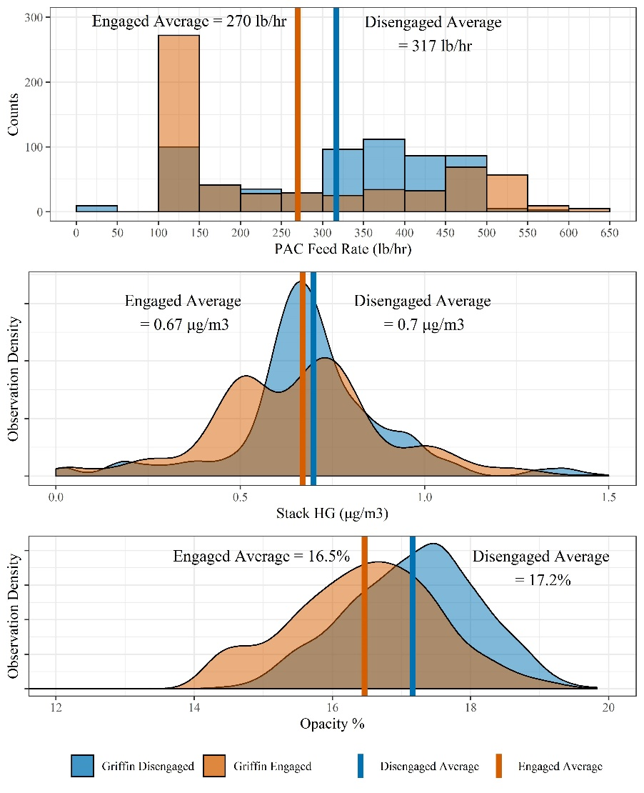
PAC Feedrate Optimization using the Griffin AI Toolkit
The minimization of mercury (Hg) emissions is a high priority for many coal-burning processes in order to meet environmental limits. A common mercury removal method injects pulverized activated carbon (PAC) shortly after combustion to adsorb mercury from the flue-gas stream. PAC injection, however, can be expensive and have detrimental effects on other aspects of the system, primarily exit gas stream opacity out the stack. It is preferable to inject only the minimum necessary amount of PAC to lower mercury below limits while not wasting PAC material and inflating opacity measurements. Common PAC injection control systems operate very slowly due to the nature of the adsorption process and the extremely low concentrations of mercury; however, the effects of injection can rapidly raise opacity, often beyond acceptable limits, requiring manual corrective actions. This often creates a cycle of control movements which culminate in the entire process performing inefficiently. There exists an opportunity to intelligently balance priorities and optimize PAC injection rates to remove mercury while controlling opacity and minimizing PAC usage.
Griffin Open Systems’ Hg PAC Optimization application successfully prioritizes multiple objectives in real-time to achieve optimal performance of your system while respecting all process limits. Through an advanced method of prioritization, long- and short-term objectives of multiple parameters are considered and respected, leading to overall improved performance.
Using this advanced platform utilizing minimal I/O and requiring less than a week to install, up to a 15% – 20% reduction in PAC injection is achievable, while lowering the occurrence of high opacity and maintaining similar or improved mercury emissions.
We at Griffin Open Systems look forward to aiding you in achieving optimal performance of your cooling towers as well as all systems within your process. Please contact us at _______@griffinopensystems.com or visit us at www.griffinopensystems.com to learn more about our many solutions today!

